**SOP01 Attachment 6**

**Collection of Plastic Inhaler Casings from Community Pharmacies**

All sections to be numbered and indexed to facilitate rapid access to relevant information

# IMPORTANT: For a procedure attached to or within a Trust policy, sections 1 to 6 only are needed using the same document control sheet as the host policy. For standalone or local procedures not linked to a Trust policy sections 1 to 9 must be completed along with the document control template above.

# Procedure Statement (Purpose / Objectives of the Procedure)

The purpose of this procedure is to set out practical guidelines for collecting and recycling the outer plastic inhalers casings from community pharmacies across Wolverhampton.

# Accountabilities

It is the Waste Managers responsibility for ensuring that the direct workforce implement the requirements of this procedure.

# Procedure/Guidelines Detail / Actions

The purpose of this scheme is to collect used and unwanted inhalers from members of the public, separate the cannister and facilitate the recycling of the plastic component.

The plastic outer casings from metered dose inhalers (including Easibreathe inhalers and Autohalers) will be collected in the collection bin provided by the Royal Wolverhampton NHS Trust.

The inhaler canisters are to be separated from the plastic component put in a yellow or blue bodied sealable container with a blue lid, these will be collected and disposed by the clinical waste contractor for the Pharmacy.

The following images contain examples of the types of inhalers that can be collected

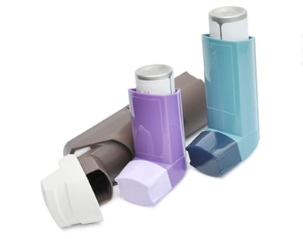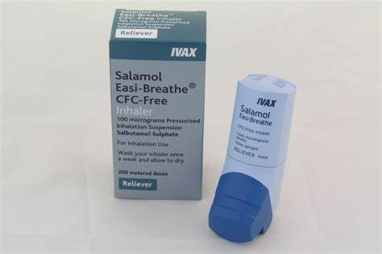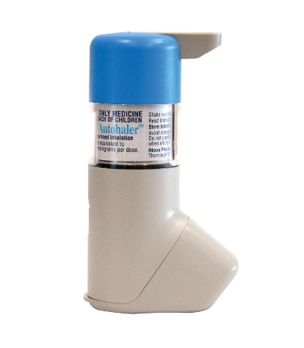

The cannister must be separated from the plastic component of the inhaler before being placed in the recycling bin.

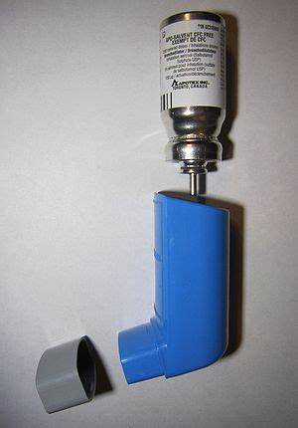

**Requirements**

Only competent permitted staff are allowed to collect the outer plastic casings.

Initial checks

1. Only an **ADR (A**greement concerning the International Carriage of **D**angerous Goods by **R**oad**)** Driveris permitted to collect the outer plastic casings.
2. The driver **must** take 2 X 240L wheeled bins with them to put the sacks of outer plastic casings in for transport back to New Cross waste yard.
3. Make sure the driver has a Hazardous Waste Consignment Note.

Requirements for start of collection from pharmacies

1. When the bins are delivered the pharmacy will be issued with an Annual Duty of Care Waste Transfer Note for the collections within that 12-month period. This will be renewed every 12 months
2. The annual Duty of Care Waste Transfer Note **MUST** be retained by the pharmacy for 2 years.
3. The pharmacy **MUST** put a clear waste sack into the bin provided, this will ensure that the items in the sack can be checked for any non-conforming waste.
4. The Pharmacist **MUST** store the inhaler outer case bin behind the counter out of reach of the public. The pharmacist staff are to take the inhalers from the member of the public and separate the canister from the inhaler, which will in the blue lidded container and put the plastic element in the bin provided.
5. When the bin is ¾ full the pharmacist must contact the New Cross waste team via the generic email that will be on the sticker of the bin to arrange a collection

([rwh-tr.wastemanagement@nhs.net](mailto:rwh-tr.wastemanagement@nhs.net))

Once collection of inhaler service starts

1. Once the email is received management will try and get a collection within 7 working days.
2. The ADR driver will attend site, introduce themselves on arrival.
3. The pharmacist will give the clear sack with the inhaler outers to the ADR driver.
4. The ADR driver will check the contents of the sack for non-conforming waste.
5. Small amounts of non-conforming waste will be removed, this waste will be given to the pharmacist so they can dispose of the waste correctly.
6. Large amounts of non-conforming waste will not be sorted at the pharmacy, it will be taken back the waste yard and sorted and recycled or disposed of correctly, the pharmacy manager be informed and given a Hazardous Waste Consignment Note.
7. If the waste continues to be non-conformant the service will be withdrawn.

Inclement weather conditions

In some inclement weather the service may not go ahead or be delayed, however, the waste management team will inform the pharmacies affected.

All incidents and accidents regardless how minor Must be reported to the Estates helpline and your manager immediately.

# Equipment Required

**Personal Protective Equipment (PPE)**

Before collecting outer plastic casings, the following PPE must be worn.

1. Gloves (issued)
2. Work wear (Trust issued uniform)

2 X 240L wheeled bins.

# Training

1. The collection driver must have a valid full driving license and an up-to-date ADR license (competency training required every 5 years through a CPC qualification)
2. The collection driver must have completed module 2 internal waste training, not mandatory, with the exception of the waste collection staff.
3. The driver must have read and signed to say that he/she has read and understood the RA and the SOP for the collection of the outer plastic inhaler casings.
4. The driver must have the knowledge and experience of completing a singular or annual Waste Transfer Notes or Hazardous Waste Consignment Note for non-conformance collections. Understand the regulations for the reason for completing these, this knowledge can be shared with the pharmacist if required.

.

# Financial Risk Assessment (where assessed in the policy does not need to be repeated for the procedure)

|  |  |  |
| --- | --- | --- |
| 1 | Does the implementation of this document require any additional Capital resources | Yes – No |
| 2 | Does the implementation of this document require additional revenue resources | Yes – No |
| 3 | Does the implementation of this document require additional manpower | Yes – No |
| 4 | Does the implementation of this document release any manpower costs through a change in practice | Yes – No |
| 5 | Are there additional staff training costs associated with implementing this document which cannot be delivered through current training programs or allocated training times for staff. | Yes – No |
|  | Other comments |  |

# Equality Impact Assessment (where assessed in a Trust policy or other local document does not need to be repeated for the procedure – simply refer to main assessment outcomes)

An equality analysis has been carried out and it indicates that:

|  |  |
| --- | --- |
| Tick | Options |
| ✓ | 1. There is no impact in relation to Personal Protected Characteristics as defined by the Equality Act 2010. |
|  | 1. There is some likely impact as identified in the equality analysis. Examples of issues identified, and the proposed actions include: |

# Maintenance

# The waste management team will review the document every 12 months or if there are any regulation or operational changes which ever comes sooner.

# Communication and Training

Communication and training will be undertaken by the sustainability team at The Royal Wolverhampton NHS Trust and will be facilitated by the Local Pharmaceutical Committee.

# Audit Process

# The pharmacies will request a collection, each time the driver attends the pharmacy he/she will inspect the sack for any non-conformances, as per the SOP.

# If there is a continuance of non-conformities the service will be withdrawn.

# After 12 months of the service commencing each pharmacy will receive a spread sheet, this will include the collection dates and the arrange weight of inhaler plastic outer casing that were collected during that period.

# Recycle UK plastic recycling contractor for the Trust. They have been audited by the RWT Waste Manager, they are compliant, and a Duty of Care audit (DoC) will be carried every12 months to ensure continuous compliance.

# 

# References

**Legal, professional or national guidelines** must underpin policies and be referenced here. Where appropriate cross references must be made to other policies.

All references to appendices and attachments within the body of the must be highlighted in blue to enable hyperlinks to be incorporated.

**Part A - Document Control**

**For Trust-wide Procedures and Guidelines - To be completed when submitted to the appropriate committee for consideration/approval (Please remove this highlighted information when using the template)**

**These templates MUST be used for all local i.e. Divisional/Directorate/Department Procedure documents developed or review after May 2017. (Please remove this highlighted information when using the template)**

|  |  |  |  |  |
| --- | --- | --- | --- | --- |
| Procedure/  Guidelines number and version | **Title of Procedure/Guidelines**  Collection of Plastic Inhaler Casings from Community Pharmacies V1.0 | **Status:**  Draft | | **Author:** Jamie Haines  **For Trust-wide Procedures and Guidelines Chief Officer Sponsor: title**  **For local procedures and guidelines Lead Sponsor (either clinical/**  **managerial lead)** |
| Version / Amendment History | Version | Date | Author | Reason |
| V1.0 | April 2023 | Jamie Haines | Implementation |
|  |  |  |  |
| **Intended Recipients:** Community pharmacists and pharmacy staff involved in the collection of inhalers. Waste and recycling staff involved in the collection | | | | |
| **Consultation Group / Role Titles and Date:** | | | | |
| **Name and date of group where reviewed** | |  | | |
| **Name and date of final approval committee(if trust-wide document)/ Directorate or other locally approved committee (if local**  **document)** | |  | | |
| **Date of Procedure/Guidelines issue** | |  | | |
| **Review Date and Frequency** (standard review frequency is 3 yearly unless otherwise indicated – see section 3.8.1 of Attachment 1) | | 2026 (3 yearly) | | |

|  |  |  |
| --- | --- | --- |
| **Training and Dissemination:** How will you communicate the document, cascade the information and address training? | | |
| **Publishing Requirements: Can this document be published on the Trust’s public page:**  **Yes / No**  If yes you must ensure that you have read and have fully considered it meets the requirements outlined in sections 1.9, 3.7 and 3.9 of [OP01, Governance of Trust-wide Strategy/Policy/Procedure/Guidelines and Local Procedure and Guidelines](http://trustnet.xrwh.nhs.uk/strategies-policies/corporate-policies-procedures-guidelines/operational-policies/op01-governance-of-trust-wide-strategy-policy-procedure-guidelin/), as well as considering any redactions that will be required prior to publication. | | |
| **To be read in conjunction with:** State the name / s of any other relevant policies / procedures. | | |
| **Initial Equality Impact Assessment: Completed Yes / No Full Equality Impact assessment (as required): Completed Yes / No / NA** If you require this document in an alternative format e.g., larger print please contact Policy Management Officer 85887 for Trust- wide documents or your line manager or Divisional Management office for Local documents. | | |
| **Contact for Review** | | This must match the author of the procedure/guideline if different please  state the contact by job title. |
| **Monitoring arrangements** | | Briefly state the monitoring report and key committee receiving the report. |
| **Document summary/key issues covered.** Please provide a brief summary of the document  to direct staff attention as to its main purpose and content. | | |
| **Key words for intranet searching purposes** |  | |

**(Part B) Ratification Assurance Statement**

**Name of document:**

**Name of author: Job Title:**

I, the above named author confirm that:

• The Strategy/Policy/Procedure/Guidelines (please delete) presented for ratification meet all legislative, best practice and other guidance issued and known to me at the time of development of the said document.

• I am not aware of any omissions to the said document, and I will bring to the attention of the Executive Director any information which may affect the validity of the document presented as soon as this becomes known.

• The document meets the requirements as outlined in the document entitled Governance of Trust- wide Strategy/Policy/Procedure/Guidelines and Local Procedure and Guidelines(OP01).

• The document meets the requirements of the NHSLA Risk Management Standards to achieve as a minimum level 2 compliance, where applicable.

• I have undertaken appropriate and thorough consultation on this document and I have detailed the names of those individuals who responded as part of the consultation within the document. I have also fed back to responders to the consultation on the changes made to the document following consultation.

• I will send the document and signed ratification checklist to the Policy Management Officer for publication at my earliest opportunity following ratification.

• I will keep this document under review and ensure that it is reviewed prior to the review date.

Signature of Author:

Date:

Name of Person Ratifying this document (Chief Officer or Nominee):

Job Title:

Signature:

• I, the named Chief Officer (or their nominee) am responsible for the overall good governance and management of this document including its timely review and updates and confirming a new author should the current post-holder/author change.

To the person approving this document:

Please ensure this page has been completed correctly, then print, sign and email this page only to: The Policy Management Officer

**IMPLEMENTATION PLAN**

**To be completed when submitted to the appropriate committee for consideration/approval**

|  |  |  |  |
| --- | --- | --- | --- |
| **Procedure/Guidelines number and version** | **Title of Procedure/Guidelines** | |  |
| **Reviewing Group** |  | | **Date reviewed:** |
| **Implementation lead: Print name and contact details** | | | |
| **Implementation Issue to be considered (add additional issues where necessary)** | | **Action Summary** | **Action lead / s (Timescale for**  **completion)** |
| Strategy; **Consider** (if appropriate)   1. Development of a pocket guide of strategy aims for staff 2. Include responsibilities of staff in relation to strategy in pocket guide. | |  |  |
| Training; Consider   1. Mandatory training approval process 2. Completion of mandatory training form | |  |  |
| Development of Forms, leaflets etc.; Consider   1. Any forms developed for use and retention within the clinical record **MUST** be approved by Health Records Group prior to roll out. 2. Type, quantity required, where they will be kept / accessed/stored when completed | |  |  |
| Procedure/Guidelines communication; Consider  1. Key communication messages from the policy / procedure, who to and how? | |  |  |
| Financial cost implementation Consider Business case development | |  |  |
| **Other specific issues / actions as required e.g. Risks of failure to implement, gaps or barriers to implementation** | |  |  |